A Project Report

on

**Virtual Trial Room**

Submitted in partial fulfillment of the requirement of Project-IV

BEG479CO

of

Bachelor of Computer Engineering

**Submitted to:**



Purbanchal University

Biratnagar, Nepal

**Submitted by:**

Sandesh Dhungana (382722)

Roshan Kumar Mahato (381574)

Manisha Gaire (381569)

**KANTIPUR CITY COLLEGE**

Putalisadak, Kathmandu

September, 2023

A Project Report

on

**Virtual Trail Room**

Submitted in partial fulfillment of the Project IV

BEG479CO

of

Bachelor in Computer Engineering

**Submitted to:**

Pubanchal University

Biratnagar, Nepal

**Submitted by:**

Sandesh Dhungana (382722)

Roshan Kumar Mahato (381574)

Manisha Gaire (381569)

Project Supervisor

Mr. Ramesh Parajuli

Supervisor

**KANTIPUR CITY COLLEGE**

Putalisadak, Kathmandu

September, 2023

# TOPIC APPROVAL SHEET

It is hereby informed that the topic selected by Sandesh Dhungana (382722), Roshan Kumar Mahato (381574), Manisha Gaire (381569) of BCE VIII semester for their semester project has been found suitable as per the credit assigned by Purbanchal University (PU), Biratnagar, Nepal.

The project Committee has approved the following topic for the above-mentioned students.

Topic Approved: **Virtual Trial Room**

Computer Department

Date: 2023/06/19

# CERTIFICATE FROM SUPERVISOR

This is to certify that the project entitled "Virtual Trial Room," submitted by Sandesh Dhungana (382722), Roshan Kumar Mahato (381574), and Manisha Gaire (381569) to the Department of Information Technology, School of Science and Technology at Kantipur City College, Kathmandu, Nepal, for the fulfillment of the requirement for BEG479CO, is an original work carried out by them under my supervision and guidance.

Signature:

Mr. Ramesh Parajuli

Project Supervisor

Department of Computer Engineering

Kantipur City College

Putalisadak, Kathmandu

Date: 2023/09/07

# Project Abstract

The Virtual Trial Room (VTR) project offers a convenient and innovative shopping experience through virtual reality technology. Customers can try on clothes virtually by creating a lifelike avatar and selecting from a wide range of clothing items. The virtual garments adapt to the customer's body shape, providing an accurate visualization of fit and style. Using computer and internet, users can easily access the system and mix and match different clothes to match their perfect outfits. For retailers, the VTR project provides valuable insights into customer preferences, helping optimize inventory and improve marketing strategies. Privacy is a priority, with personal data handled confidentially, and customers have the option to use anonymous avatars. The VTR project transforms the fashion retail landscape, promoting sustainability by reducing physical trials and embracing the digital era of shopping.

# Acknowledgements

I extend my sincere appreciation to Mr. Ramesh Parajuli for his exceptional supervision and guidance throughout the Virtual Trial Room (VTR) project. His expertise played a crucial role in its success. I am also grateful to the Computer Department at Kantipur City College for their constant support and guidance. Their invaluable assistance, along with the encouragement from my fellow classmates, made this project possible. Lastly, I extend my heartfelt thanks to all the faculty members for providing guidelines and ensuring the completion of this project report in the prescribed format. Their contributions have been instrumental in shaping these endeavors.

# Preface

Welcome to the Virtual Trial Room (VTR) project! This is a special project where we mix technology and fashion to change how we shop for clothes.

We had a great idea to make shopping more fun and easier. With the help of our teacher, Mr. Ramesh Parajuli, and support from our college's Computer Engineering Department, we worked hard to make this project a reality.

In this document, we share our journey and show how you can try on clothes virtually using your computer. We hope this project inspires better ways of shopping and brings joy to all fashion lovers.

Thank you for being part of our exciting adventure!

Sandesh Dhungana (382722)

Roshan Kumar Mahato (381574)

Manisha Gaire (381569)

# DECLARATION

We hereby declare that this project, titled "Virtual Trial Room," submitted in partial fulfillment of the Bachelor in Computer Engineering VIII semester at Kantipur City College, is a record of original work carried out by us under the supervision of Mr. Ramesh Parajuli. This project has not formed the basis for the award of any other degree or diploma, in this or any institution or university. Throughout this project, we have upheld ethical practices in reporting scientific information, giving proper acknowledgment to others' contributions wherever applicable. We affirm the authenticity of all the data, results, and conclusions presented in this project, achieved through diligent research and analysis, and have accurately cited all sources and references used. This declaration reflects our commitment to academic integrity and ethical conduct in our pursuit of knowledge and research.

Sandesh Dhungana (382722)

Roshan Kumar Mahato (381574),

Manisha Gaire (381569)

# CERTIFICATE FROM THE DEPARTMENT

Following the Supervisor’s Approval and Examiners’ Acceptance, the project entitled “Virtual Trial Room” submitted by Sandesh Dhungana (382722), Roshan Kumar Mahato (381574), and Manisha Gaire (381569) as a partial fulfillment of the requirements for the degree of Bachelor in Computer Engineering, VIII semester under Purbanchal University, has been officially awarded by this certificate.

I wish all the students all the best for their future endeavors.

Er. Subash Rajkarnikar

Head of the Computer Engineering Department

Date: 2023/09/07

# Abbreviation

1. VTR = Virtual Trial Room
2. ROI = Region of Interest
3. CNN = Convolution Neural Network
4. RCNN = Regional Convolution Neural Network
5. UNet = U Shaped Network Layer Architecture
6. DFD = Data Flow Diagram
7. Info = Information

Table of Contents

TOPIC APPROVAL SHEET i

CERTIFICATE FROM SUPERVISOR ii

Project Abstract iii

Acknowledgements iv

Preface v

DECLARATION vi

CERTIFICATE FROM THE DEPARTMENT vii

Abbreviation viii

1 Introduction 1

1.1 Overview 1

1.2 Problem Statement 2

1.3 Objectives 3

1.4 Features 3

1.5 Significance 3

1.6 Scope and Limitations 4

1.7 Organization of the Document 5

2 Literature Review 6

2.1 LensKart: 7

2.1.1 Pros: 7

2.1.2 Cons: 7

2.2 Eyeconic: 7

2.2.1 Pros: 8

2.2.2 Cons: 8

3 Methodology 9

3.1 Software Development Life Cycle 9

3.1.1 Model 11

3.2 Technologies and Tools used 11

3.2.1 Programming Language used 11

3.2.2 Database used 12

3.2.3 Datasets used 12

3.2.4 Integrated Development Environment (IDE) 13

3.2.5 Technologies used than recommended 13

3.3 Assignment of Roles and Responsibilities 14

4 System Analysis 15

4.1 Requirement Analysis 15

4.1.1 Requirement Gathering 15

4.1.2 Functional Requirements 15

4.1.3 Non-Functional Requirements 16

4.2 Feasibility Study 16

4.2.1 Technical Feasibility 16

4.2.2 Economic Feasibility 17

4.2.3 Schedule Feasibility 17

5 System Design 19

5.1 System Architecture 19

5.2 Procedure Oriented 20

5.2.1 Data Flow Diagram 20

5.2.2 Level 1 DFD 20

5.2.3 Use Case Diagram 21

5.2.4 Unet Architecture 22

5.2.5 Model Architecture 22

6 System Development and Implementation 23

6.1 Programming Platform 23

6.2 Operating Environment 23

7 Testing and Debugging 24

7.1 Tools Used in Testing 24

7.2 Test Case 24

8 Conclusion 28

9 References 29

**List of Figures**

Fig 3.1 Modified Prototype Model with MLDLC 10

Fig 3.1.1 Prototype Model 11

Fig 5.1.1: System Architecture Diagram 19

Fig 5.2.1 Virtual Trial Room DFD 20

Fig 5.2.3 Level 1 DFD 20

Fig 5.2.4 Use Case Diagram 21

Fig 5.2.5 Model Architecture 22

**List of Tables**

Table 3.3 Roles and Responsibilities 14

Table 4.1.1 Requirements 15

Table 4.1.2 Functional Requirements 16

Table 4.1.3 Non-Functional Requirements 16

Table 4.2.3.1 Gantt Chart 18

Table 7.1 Tools 24

Table 7.2 Test Case I 24

Table 7.2 Test Case II 25

Table 7.2 System Test 26

# 1 Introduction

Introducing the Virtual Trial Room (VTR) project, a unique blend of fashion and technology that transforms the way we shop for clothes. With the VTR, you can explore an exciting new way to try on clothes without visiting a physical store. By uploading your picture and selecting your preferred clothing items from a vast collection, the VTR utilizes computer programs and machine learning models trained on limited datasets to virtually showcase how the chosen clothes look on you.

The VTR project strives to make shopping more convenient and personalized for everyone. It saves valuable time by eliminating the need for physical try-ons, enabling you to visualize different outfits and find the perfect style that suits you best. Not only does this benefit shoppers, but it also provides valuable insights to stores about customer preferences.

## Overview

The Virtual Trial Room (VTR) project is an exciting innovation that revolutionizes the fashion shopping experience. Developed using Python programming language, this project is designed to provide a unique and interactive platform for users to virtually try on clothes. The system utilizes limited datasets and runs on simple hardware devices, making it accessible to a wide range of users.

At the heart of the VTR project lies a series of powerful machine learning models, each serving a specific purpose. These models include clothing semantic segmentation, pose estimation, data segmentation, and cloth try-on visualization. Together, they create a dynamic and realistic virtual try-on experience for users, allowing them to see how different clothing items would look on their own image.

The clothing semantic segmentation model intelligently separates the clothes from the background, allowing for accurate visualization and fitting. The pose estimation model ensures that the virtual clothes align with the user's body posture, providing a seamless and realistic experience.

The data segmentation model plays a crucial role in generating precise results. By identifying and separating the key features of clothing, such as sleeves, collars, and hemlines, it ensures that the virtual garments conform to the user's body shape. The cloth try-on visualization model then combines the chosen clothes with the user's image, displaying the final result as if the user is trying on the clothes physically. Additionally, the use of limited datasets ensures that the project remains lightweight while maintaining impressive performance.

The e-commerce clothing website, with Python-based backend, serves as a conceptual illustration for integrating a Virtual Trial Room into the business model. While the virtual fitting feature is not yet implemented, the site outlines the blueprint for how this technology could enhance the online shopping experience by enabling customers to virtually "try on" garments before making a purchase. The planned addition aims to bridge the gap between online and in-store shopping, offering a more interactive and personalized user experience.

## Problem Statement

In today's digital age, online businesses, particularly clothing retail, have been booming. However, one major challenge faced by consumers is buying clothes online without the opportunity to physically try them on. Without the ability to see how the clothes look and fit on themselves, buyers face uncertainty and risk purchasing clothes that may not suit them well. This often results in the inconvenience of returning items, causing losses for the seller due to refunds and dissatisfied customers.

To tackle this issue and improve the online shopping experience, our project, the Virtual Trial Room (VTR), comes to the rescue. **The VTR provides buyers with a unique and interactive solution to virtually try on clothes before making a purchase.** With the help of advanced machine learning models, the VTR enables users to upload their images and select desired clothing items from a diverse collection. By doing so, buyers can visualize how the chosen clothes look on their own images, just like trying them on in a physical store.

For sellers, the VTR minimizes returns and refunds, leading to more satisfied customers and improved inventory management. With the VTR, we aim to revolutionize the way we shop for clothes online, providing an enjoyable shopping experience for both buyers and sellers.

## Objectives

* To achieve realism, the VTR utilizes advanced machine learning for clothing segmentation, pose estimation, and cloth try-on visualization.
* To offer a virtual try-on experience where users can upload images and select cloth image from a diverse collection.

## Features

* **Clothing Selection**: Users can select their preferred clothing items from a diverse collection, allowing them to explore various styles and combinations before making a purchase.
* **Virtual Try-On**: Users can virtually try on clothes by uploading their images and visualizing how the chosen clothes look on themselves without physically wearing them.

## Significance

The significance of this project lies in its potential to revolutionize the e-commerce landscape for clothing retailers. By integrating Virtual Trial Room into an existing online platform, the project not only enhances the user experience but also addresses one of the most pressing challenges in online fashion retail: the inability to try before you buy. This innovation could dramatically reduce return rates, save on operational costs, and provide valuable insights into consumer behavior. Furthermore, it creates the way for a more interactive and personalized online shopping experience, potentially setting a new standard in the industry.

## Scope and Limitations

The scope of this project in business and real-world applications is immense. From a business perspective, the integration of a Virtual Trial Room could become a competitive advantage, attracting a larger customer base also reducing return costs. In terms of real-world impact, the technology could make online shopping more accessible for people who are constrained by mobility, or time. It can also serve as a model for other retail sectors, showcasing how digital transformations can enrich the customer experience. Overall, the project shows the potential to set new benchmarks in e-commerce, making shopping more efficient, personalized, and sustainable.

* Competitive Advantage
* Customer Analytics
* Accessibility

While the concept of a Virtual Trial Room presents exciting opportunities, it comes with inherent limitations. As the system is yet to be fully implemented, its efficacy in a real-world setting remains untested. The technology demands high-quality images for accurate virtual fitting, which could exclude users with lower-end cameras. Additionally, the speed and effectiveness of the virtual try-on are heavily reliant on high-processing CPU and GPU capabilities, potentially making the feature slow and less accessible with older or less powerful hardware. These technical requirements could limit widespread adoption and hamper the user experience.

* Not Yet Implemented on E-commerce sites
* Requires High-Quality Images
* Limited Accessibility
* Untested Efficacy in Real-World Setting

## Organization of the Document

**Chapter1** (Introduction): It includes the topic introduction and describe about what is this project is about, its objective, features, significance, scope and limitations of the system.

**Chapter 2** (Literature review): It includes the description of existing system with its pros and cons.

**Chapter 3** (Methodology): It explains the SDLC model that is being used in the system and also includes description of tools and technology used to develop the system. It has also description of roles and responsibilities of the team member.

**Chapter 4** (System Analysis): It show the requirement analysis, requirement gathering and functional requirement of the system.

**Chapter 5** (System Design): This chapter explains the figure of the system.

**Chapter 6** (System Development and Implementation): This describes the programming platform and operating environment being used.

**Chapter 7** (Testing and debugging): This shows every testing that are done to check the functionality of the system.

**Chapter 8** (Conclusion): This chapter concludes the project documentation.

**Chapter 9** (References): The references that are taken during development process are included in this section.

# 2 Literature Review

**Clothing Segmentation with Latent Diffusion:**

* "Latent Diffusion for Image-based Virtual Try-On" paper shows how to neatly wrap virtual clothes for trying on.
* D. Morelli, A. Baldrati, G. Cartella, M. Cornia, M. Bertini, and R. Cucchiara, "LaDI-VTON: Latent Diffusion Textual-Inversion Enhanced Virtual Try-On," in Proceedings of the ACM International Conference on Multimedia, 2023.

**Datasets for Learning:**

* "DeepFashion2" dataset gives lots of different fashion pictures.
* "FashionMNIST" dataset helps in initial training.
* Zalando Research. "Fashion MNIST." Available online: https://github.com/zalandoresearch/fashion-mnist

**Learning Convolution and Pooling:**

* "3Blue1Brown" YouTube channel helped understand image processing like convolution, pooling, padding.
* https://youtube.com/3Blue1Brown/neuralnetworks.

**Building Neural Networks with PyTorch:**

* PyTorch guide helped in making smart networks models.
* "PyTorch Documentation." PyTorch, Available online: https://pytorch.org/docs/stable/index.html

**Spotting Clothes with Detectron2:**

* "Detectron2" finds clothes and important points on image uploaded.
* Y. Wu, A. Kirillov, F. Massa, W.-Y. Lo, and R. Girshick, "Detectron2," 2019. [Online]. Available: https://github.com/facebookresearch/detectron2

**Face Shapes with MediaPipe:**

* "MediaPipe" makes virtual clothes fit faces well.
* https://doi.org/10.48550/arXiv.1906.08172

**Fancy Images with Latent Diffusion:**

* Using latent diffusion makes pictures of clothes look nice.
* D. Morelli, A. Baldrati, G. Cartella, M. Cornia, M. Bertini, and R. Cucchiara, "LaDI-VTON: Latent Diffusion Textual-Inversion Enhanced Virtual Try-On," in Proceedings of the ACM International Conference on Multimedia, 2023.

Based on the project content I have studied these research paper and existing system mentioned below.

## 2.1 LensKart:

Lenskart's "Try On" feature is a convenient tool that lets buyers, or anyone virtually try on eyeglasses and sunglasses without needing to visit a store. It uses technology to superimpose the glasses onto a picture of your face. This way, you can see how different frames look on you, helping you pick the perfect pair that suits your style before you make a purchase.

Link : https://www.lenskart.com/compare-looks

### 2.1.1 Pros:

* Convenient Virtual Fitting: Try on eyeglasses and sunglasses from home.
* Accurate Visualization: Realistic experience for better decision-making.
* Diverse Style Exploration: Try with various styles and colors.

### 2.1.2 Cons:

* Limited In-Person Assistance: Lack of in-person assistance for frame selection.
* Screen Accuracy: Variability in how frames appear due to screen differences.
* Fit and Comfort: Inability to physically try on frames for comfort and fit.

## 2.2 Eyeconic:

Eyeconic offers an advanced shopping experience for eyewear enthusiasts, complete with a "Virtual Try-On" feature that revolutionizes how the user selects glasses and sunglasses. Explore an extensive collection, then utilize the virtual try-on to record a quick video and see how the eyewear looks on the user's face. If the buyer is content, they can easily add their preferred choices to the bag and proceed to checkout, all from the comfort of their own home. Eyeconic's innovative approach combines style exploration with the convenience of online shopping, ensuring that the buyer discovers the ideal eyewear to enhance their look.

Link: https://www.eyeconic.com/

### 2.2.1 Pros:

* Virtual Try-On: See how eyewear looks before buying.
* Diverse Selection: Wide range of styles, brands, and colors.
* Convenient Online Shopping: Explore, try on, and purchase from home.

### 2.2.2 Cons:

* Dependency on Technology: Requires a device with a camera for the virtual try-on feature.
* Screen Accuracy: Variability in appearance due to screen differences.
* Video Capture Requirement: Need to record a video for virtual try-on.

# 3 Methodology

In developing our Virtual Trial Room system, the Prototype Model is deemed highly appropriate for several reasons. The requirements of the complete system are well-defined, yet some functionalities are expected to evolve over time due to technological advancements and feedback. Additionally, the project will make use of emerging technologies. Resources with specific skill sets, especially in machine learning, will be contracted for targeted iterations. Machine learning development will also follow its own life cycle, including data gathering, preparation, preprocessing, analysis, model training, and testing. This iterative approach benefits the project by allowing for early detection of functional or design flaws, thereby managing high-risk features more effectively. However, the model comes with its own set of challenges, including the potential for increased resource requirements and management complexity. Despite these challenges, the advantages such as early functionality, risk management, and adaptability to changing requirements make this model well-suited for our large and mission-critical project.

## 3.1 Software Development Life Cycle

The Virtual Trial Room project incorporates both the **Prototype Model** and the **Machine Learning Development Life Cycle (MLDLC)** to ensure a robust and complete system. The Iterative Prototype Model is particularly a well suited for this project due to its ability to produce early working functionalities, a critical need given our time to complete project and evolving requirements. It allows for incremental improvements, letting us adapt to emerging technologies. On the model building side, the MLDLC guides the data gathering, preparation, and preprocessing stages, leading to the training and testing of neural networks crucial for features like clothing segmentation and virtual fitting. Combining these two life cycles offers a structured yet flexible approach. The iterative model enables early validation and risk management, while the MLDLC ensures the machine learning algorithms like Regional Convolution Network (RCNN) are optimized for performance. Together, they offer a complete plan that handles the project's challenges, making them the best choices for building this system.

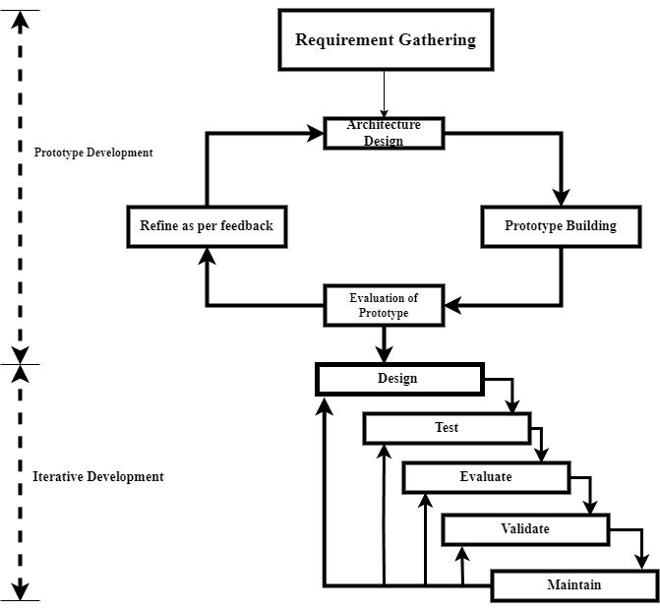

Fig 3.1 Modified Prototype Model with MLDLC

### 3.1.1 Model

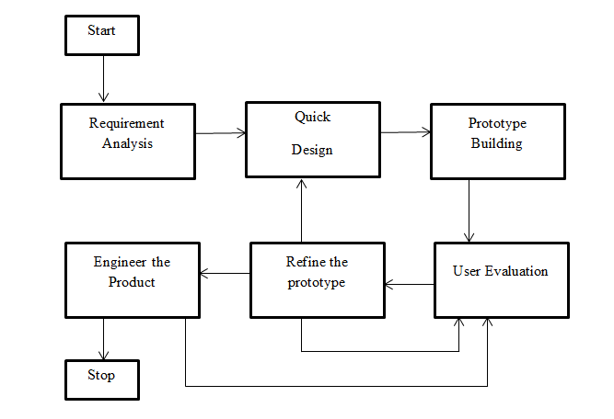

#### Fig 3.1.1 Prototype Model

## 3.2 Technologies and Tools used

### 3.2.1 Programming Language used

Python serves as the core programming language for the Virtual Trial Room project, offering a rich ecosystem of specialized libraries. PyTorch and TensorFlow are used for machine learning tasks like clothing segmentation. NumPy aids in numerical operations, while Matplotlib handles data visualization. OpenCV is crucial for computer vision tasks such as fitting virtual clothes onto users. Ninja speeds up the build process. For the e-commerce website portion, Django is used to facilitate rapid development and clean design. Each tool and library have a specific role, contributing to the project's overall functionality.

* Python v3.10.12
* Matplotlib v3.7.1
* Torch v2.0.1
* OpenCV-python v4.7.0.72
* Diffusers v0.14.0
* Transformers v4.27.3
* PyYAML v5.1
* Detectron2 v0.6
* CUDA Compilation tools v11.8.89, NVIDIA 2005-2022
* Torchvision v0.15.2
* Mediapipe v0.10.3
* OpenPose v1.7.0
* Ninja v0.14.5

### 3.2.2 Database used

In our e-commerce clothing website, we are using an SQL database, specifically MySQL, to manage various types of essential data. This includes product information for articles of clothing, capturing detail like price for easy retrieval and updates. User information is securely stored to facilitate login and registration processes. Cart information is also maintained to keep track of items selected by users for potential purchase. Additionally, payment information is encrypted and securely stored in compliance with data protection regulations. The MySQL database serves as the integral foundation of our website, enabling data management and an efficient user experience.

### 3.2.3 Datasets used

In our Virtual Trial Room project, two primary datasets were employed for model building. The **DeepFashion2** dataset serves as a comprehensive source for fashion images, including a wide range of clothing items in various poses and conditions. This dataset is invaluable for training our machine learning models to accurately recognize and segment clothing items from complex backgrounds. We cite the DeepFashion2 dataset for its extensive collection and high-quality fashion images that significantly contribute to the accuracy of our models.

The **Dresscode** dataset is used mainly for initial training and validation purposes. While simpler than **DeepFashion2**, **FashionMNIST** offers grayscale images of basic fashion items, which are excellent for preliminary model testing. We cite **FashionMNIST** as a reliable, initial training dataset that aids in the early stages of our model development.

### 3.2.4 Integrated Development Environment (IDE)

In the scope of this project's documentation, it is crucial to outline the Integrated Development Environments (IDEs) used to optimize our development process. For the machine learning aspects, Google Colab v0.9.0 has been an invaluable resource. It offers free T4 GPU hardware and adequate RAM support for Python 3, facilitating efficient model training and testing up to 12 hours.

In contrast, the development of our e-commerce website is carried out using Visual Studio. This IDE provides a comprehensive suite of web development tools, ideal for building a user-friendly, scalable online clothing platform. Visual Studio is also used for data preprocessing tasks

### 3.2.5 Technologies used than recommended

Within this project documentation, it is noteworthy to mention the incorporation of emerging technologies that exceed the standard requirements of this semester's scope. Specifically, MediaPipe and Detectron2 have been vital tools in elevating the capabilities of our Virtual Trial Room.

MediaPipe is deployed for face reconstruction tasks within our system. The Virtual Trial Room may occasionally degrade the quality of the user's face during the cloth-swapping process. MediaPipe effectively restores and refines facial features, thereby maintaining a natural look in the virtual try-on experience.

Detectron2 is another crucial technology used for generating accurate poses via its OpenPose capabilities. Detectron2 excels in object detection and segmentation, making it invaluable for accurately identifying and outlining clothing items on human figures in our system.

## 3.3 Assignment of Roles and Responsibilities

##### Table 3.3 Roles and Responsibilities

|  |  |  |
| --- | --- | --- |
| Member Name | Role & Responsibilities | Task/ Activity |
| Sandesh Dhungana | Code, Documentation, Research | Coding, Documentation, Model training, testing. |
| Roshan Kumar Mahato | Code, Documentation, Dataset preparation, Research | Research, Dataset evaluation, Model Evaluation, Presentation. |
| Manisha Gaire | Code, Documentation, Dataset preparation, Research | Research, Dataset evaluation, Model Evaluation, Presentation. |

# 4 System Analysis

## 4.1 Requirement Analysis

The Requirement Analysis is a key part of our Virtual Trial Room project. It tells us what the system needs to do and what limits it has. The main goal is to let users try on clothes virtually in a quick and secure way. This part helps us understand what our Virtual Trial Room needs to have and what its limits are. This is also important step for our project with a clothing website.

### 4.1.1 Requirement Gathering

In the Requirement Gathering phase for our Virtual Trial Room project and clothing website, we list out all the specific things the system needs to do. This includes features like letting users try on clothes virtually. We label these needs with IDs like R1, R2, and so on, so it's easy to refer to them later. This step helps make sure everyone knows what the system should achieve and sets the stage for the rest of the project.

##### Table 4.1.1 Requirements

|  |  |
| --- | --- |
| Requirement ID | Description |
| R1 | Cloth Segmentation from image |
| R2 | Image masking |
| R3 | Virtual Clothes Swap |
| R4 | User Login or Authentication |
| R5 | Add to Cart |
| R6 | Payment |

### 4.1.2 Functional Requirements

For the functional requirements of this project, we've identified key features that the system must have. First, there's Image Processing (R1), which allows the virtual try-on to work in real-time. Second, we have the Virtual Clothes Swap (R2), enabling users to virtually try on different outfits. User Login or Authentication (R3) ensures that users can save preferences and items securely. The Add to Cart function (R4) lets users place their chosen items in a virtual cart for eventual purchase. Finally, the Payment function (R5) handles secure transactions

##### Table 4.1.2 Functional Requirements

|  |  |  |
| --- | --- | --- |
| Function ID | Description | Cross Reference with requirement |
| F1 | Enable Virtual Clothes Swap | R1, R2, R3 |
| F2 | User Authentication and Verification | R4 |
| F3 | Add items to cart | R5 |
| F4 | Secure Payment Processing | R6 |

### 4.1.3 Non-Functional Requirements

In this project, non-functional requirements are really important. These are the rules about how well the system should work. For example, it needs to be fast so people can use it easily, safe so that no one's data gets stolen, and simple enough that anyone can use it. Depending on what we want to achieve with the project, some of these rules might be more important than others. These rules help us know if our system is good and works the way we want it to.

##### Table 4.1.3 Non-Functional Requirements

|  |  |
| --- | --- |
| Property | Measure |
| Speed | Execution is carried out in time of approximately 20 minutes. |
| Reliability | Requires High Resolution Images. |
| Robustness | Single user at a time. |
| Usability | Available in Colab IDE. |

## 4.2 Feasibility Study

### 4.2.1 Technical Feasibility

* Utilized Colab: Leveraged Google Colab, which provides GPU and CPU resources in the cloud, to code, train, and test machine learning models.
* Resource Flexibility: Google Colab's cloud-based environment provided the flexibility to scale computing resources as needed, supporting image processing and model training.
* Remote Collaboration: Enabled remote collaboration among team members, making it easier to work on the project from different locations.
* Overcame Hardware Limitations: Successfully managed project development without access to high-end GPU-equipped devices, demonstrating resource adaptability.

### 4.2.2 Economic Feasibility

In the context of this project, economic feasibility was not a primary concern, as it was undertaken as a college project with a focus on learning, skill development, and experimentation rather than on generating revenue or assessing financial returns. The primary goal was to gain hands-on experience in developing a Virtual Trial Room integrated with an e-commerce platform, honing technical skills, and exploring innovative solutions. Therefore, a formal economic feasibility analysis, including cost-benefit assessments, ROI calculations, or revenue projections, was not conducted. Instead, the emphasis was on the educational and technical aspects of the project, with an understanding that real-world economic considerations would come into play if the project were to transition into a commercial venture.

### 4.2.3 Schedule Feasibility

The schedule feasibility for this project, which has a total time allocation of 90 hours within a semester, is attainable with proper planning and resource allocation. With a team of three members, tasks can be distributed efficiently. The project encompasses initial research and planning, system design and development, machine learning model training, rigorous testing, documentation, and presentation. By adhering to a structured timeline and effective teamwork, it is feasible to complete the project within the allocated timeframe. Regular progress monitoring and adjustments will be essential to ensure successful milestone completion.

**4.2.3.1 Gantt Chart**

##### Table 4.2.3.1 Gantt Chart

|  |  |  |  |  |  |  |  |  |  |  |  |  |  |  |  |  |  |  |  |  |  |  |  |
| --- | --- | --- | --- | --- | --- | --- | --- | --- | --- | --- | --- | --- | --- | --- | --- | --- | --- | --- | --- | --- | --- | --- | --- |
| S. N | Month | APRIL | | | MAY | | | | | June | | | | JULY | | | | AUG | | | | SEP | |
|  | Duration in Weeks/ TASK TITLE/ | 3 | | 4 | 1 | 2 | 3 | 4 | 1 | 2 | 3 | 4 | 1 | 2 | 3 | 4 | 1 | 2 | 3 | 4 | 1 | 2 |
| 1 | Project Planning |  | | | | | | | | | | | | | | | | | | | | | |
| 1.1 | Project Idea Formulation |  |  |  |  |  |  |  |  |  |  |  |  |  |  |  |  |  |  |  |  |  |
| 1.2 | Project Idea Presentation |  |  |  |  |  |  |  |  |  |  |  |  |  |  |  |  |  |  |  |  |  |
| 1.3 | Project Idea Finalized |  |  |  |  |  |  |  |  |  |  |  |  |  |  |  |  |  |  |  |  |  |
| 2 | Resource Collection |  | | | | | | | | | | | | | | | | | | | | | |
| 2.1 | Resource Collection |  |  |  | |  |  |  |  |  |  | |  |  |  |  |  |  |  |  |  |  |
| 3 | Research and Analysis |  | | | | | | | | | | | | | | | | | | | | | |
| 3.1 | Research and Analysis |  |  |  |  |  |  |  |  |  |  |  |  |  |  |  |  |  |  |  |  |  |
| 3.2 | Re-research and Analysis |  |  |  |  |  |  |  |  |  |  |  |  |  |  |  |  |  |  |  |  |  |
| 4 | System Design |  | | | | | | | | | | | | | | | | | | | | | |
| 4.1 | System Design |  |  |  |  |  |  |  |  |  |  |  |  |  |  |  |  |  |  |  |  |  |
| 4.2 | Updating System Design |  |  |  |  |  |  |  |  |  |  |  |  |  |  |  |  |  |  |  |  |  |
| 5 | Coding |  | | | | | | | | | | | | | | | | | | | | | |
| 5.1 | Coding |  |  |  |  |  |  |  |  | | | | |  |  | | | | | | |  | |
| 6 | Testing and debugging |  | | | | | | | | | | | | | | | | | | | | | |
| 6.1 | Testing and debugging |  |  |  |  |  |  |  |  |  |  | | |  |  |  |  |  |  | | |  |
| 7 | Documentation |  | | | | | | | | | | | | | | | | | | | | | |
| 7.1 | Documentation |  |  |  |  | | | | | | | | | | | | | | | | | | |

# 5 System Design

## 5.1 System Architecture

In the system design of the Virtual Trial Room and e-commerce platform, the architecture of the Virtual Trial Room (VTR) module is crucial. This module operates by processing two input images: one representing the user and the other showcasing the available clothing items. The user's image undergoes a series of transformations, including segmentation to isolate the user from the background, pose estimation, and masking to create a distinct representation. Similarly, the clothing image is segmented and masked to isolate the apparel item. Subsequently, these processed images are fed into an encoder and decoder architecture within a machine learning model. This neural network-based model combines the user's image and the clothing item, resulting in a cloth-swapped image superimposed onto the user's image.

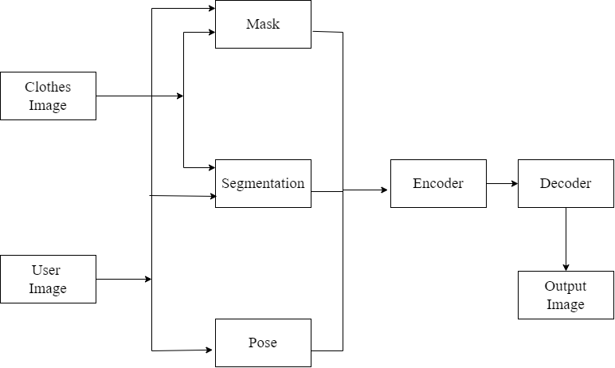

#### Fig 5.1.1: System Architecture Diagram

## 5.2 Procedure Oriented

### 5.2.1 Data Flow Diagram

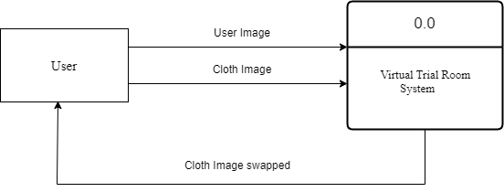

#### Fig 5.2.1 Virtual Trial Room DFD

### 5.2.2 Level 1 DFD

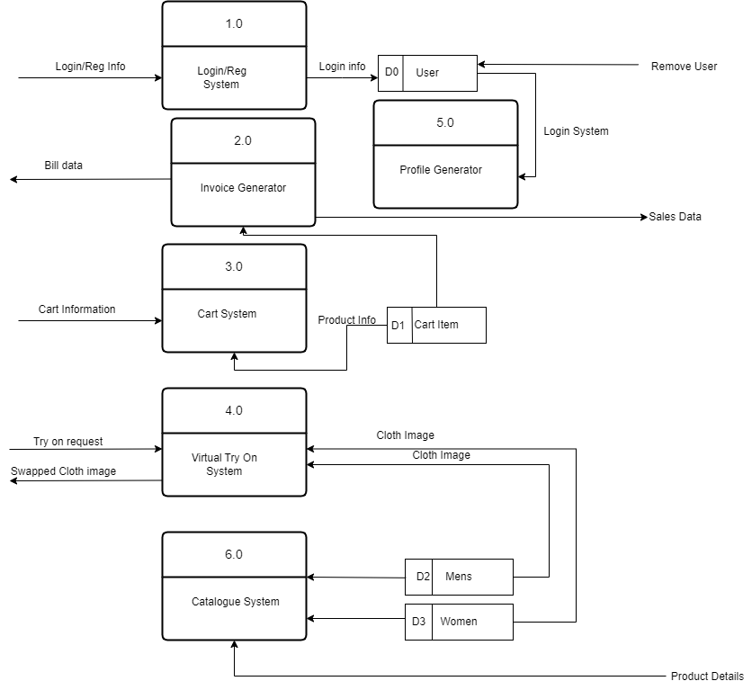

Fig 5.2.3 Level 1 DFD

### 5.2.3 Use Case Diagram

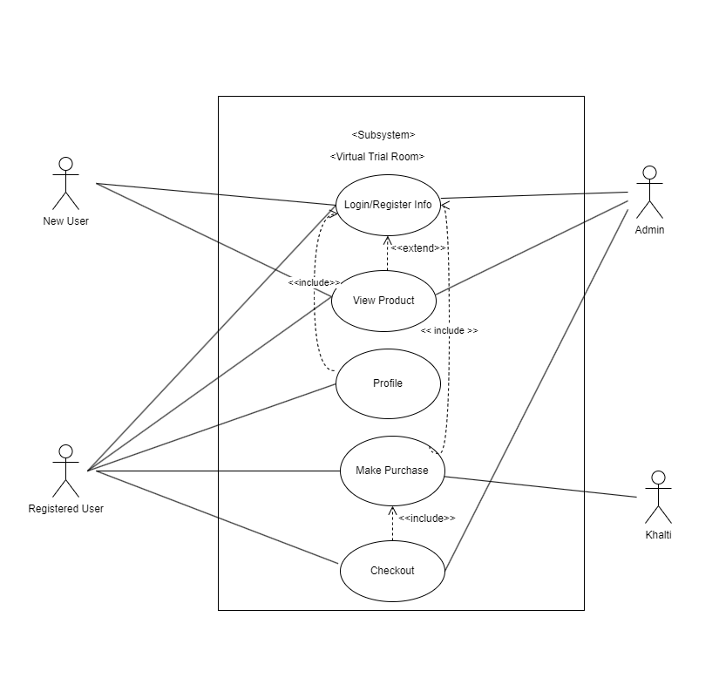

#### Fig 5.2.4 Use Case Diagram

### 5.2.4 Unet Architecture

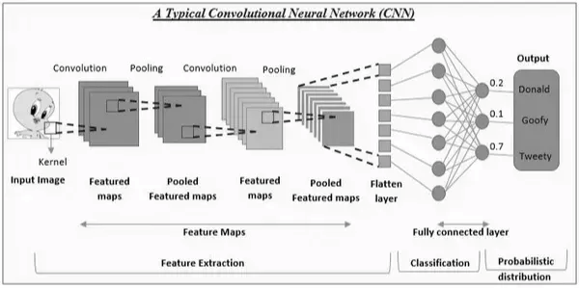

Fig 5.2.5 UNet Architecture

### 5.2.5 Model Architecture

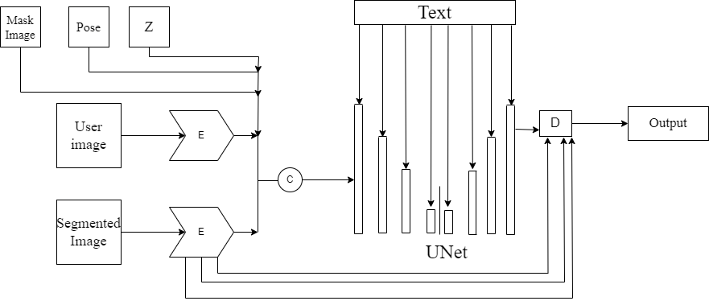

#### Fig 5.2.5 Model Architecture

# 6 System Development and Implementation

## 6.1 Programming Platform

The programming for our Virtual Trial Room project is done on a Windows 10 computer. We use an IDE (Integrated Development Environment) called Visual Studio Code Insiders to write and test our code. But for the heavy lifting, like testing our machine learning models and running the virtual trial room, we use Google Colab. Google Colab is a cloud service that gives us access to a powerful T4 GPU and more than 17 GB of RAM. This makes sure that our project runs smoothly and quickly, even when we're dealing with complex tasks.

## 6.2 Operating Environment

Virtual Trial Room project needs some pretty strong tech to work well. Specifically, we need NVIDIA for graphics because we're working with high-quality images—like making sure clothes fit right on the user in the virtual try-on. We use Google Colab for this, which comes loaded with the NVIDIA Cuda tools we need. This allows us to build, test, and run our whole virtual trial room smoothly and effectively. On the other hand, the actual clothing website isn't as demanding; 4 GB of RAM is enough for it to run well. But for the trial room part, everything is done on Google Colab to make sure it works as it should.

# 7 Testing and Debugging

The development of Virtual Trial Room had its challenges. First, we tried to make a system that could pick out clothes in a picture, but it kept getting it wrong. We fixed this by using some special settings from LaDi Vton. Then, we tried to make another system that would show the clothes on a person. This also had issues like clothes appearing in the wrong places, or colors getting mixed up. We haven't fully fixed this, but it does work.

We also had a problem with making the clothes fit the face correctly in the picture. We used a tool from Google, called MediaPipe, to help with that. Lastly, on the clothing website, we had some bugs with the shopping cart not updating correctly and pictures not showing up. These were due to some settings that were wrong, and we're working on fixing them.

## 7.1 Tools Used in Testing

##### Table 7.1 Tools

|  |  |  |
| --- | --- | --- |
| S. N | Tool | Specification |
| 1 | Hardware (Laptop) | Processor AMD Ryzen 3 3350U with Radeon Vega Mobile Gfx, 2100 Mhz, 4 Core(s), 4 Logical Processor(s) |
| 2 | Testing Software used | None |

## 7.2 Test Case

##### Table 7.2 Test Case I

|  |  |  |  |  |  |
| --- | --- | --- | --- | --- | --- |
| Model 1 Test | | | | | |
| ID | Test Case Description | Test Case Data | Expected Result | Actual Result | Status |
| T-01 | Shirt Detection | Image 25x25 | Segmentation of Shirt part | Segmentation with Noise | Failure |
| T-02 | Cloth Detection | Image | Segmentation of cloth part of image | Removed background and whole-body segmentation | Failure |
| T-03 | Feature Extraction | Image, text | Text Based information about clothes | Text Based information about clothes | Success |
| T-04 | Cloth Detection | Image, Text | Segmentation around cloth part | Memory Failure | Failure |
| T-05 | Pant Detection | Image, Text | Segmented Image as output | Segmented Image as output | Success |

##### Table 7.2 Test Case II

|  |  |  |  |  |  |
| --- | --- | --- | --- | --- | --- |
| Model 2 Test | | | | | |
| ID | Test Case Description | Test Case Data | Expected Result | Actual Result | Status |
| T-01 | Shirt swapping | 2 Images, Text | Cloth image, placed exactly over upper human image. | No image swapped; human image was output. | Failure |
| T-02 | T-Shirt swapping | 2 Images, Text | Cloth image, placed exactly over upper human image. | Cloth image, placed exactly over upper human image. | Success |
| T-03 | Pant swapping | 2 Images, Text | Cloth image, placed exactly over lower cloth of human image. | Cloth image, placed exactly over lower cloth of human image. | Success |
| T-04 | Half-Pant swapping | 2 images, Text | Pant Swapped | Pant is swapped, but half part is white, rest is same. | Failure |

##### Table 7.2 System Test

|  |  |  |  |  |  |
| --- | --- | --- | --- | --- | --- |
| System Test | | | | | |
| ID | Test Case Description | Test Case Data | Expected Result | Actual Result | Status |
| T-01 | Cloth Swapping | 2 Images, Text | Facal Structure deteriorate | Facal Structure deteriorated | Success |
| T-02 | Face reconstruction | 2 images, Text | Original Facial Structure | Original Facial Structure | Success |

|  |  |  |  |  |  |
| --- | --- | --- | --- | --- | --- |
| Website Test | | | | | |
| ID | Test Case Description | Test Case Data | Expected Result | Actual Result | Status |
| T-01 | User Login Authorization | Username, Password | Logged in | Logged in | Success |
| T-02 | User Login Authorization | Username with lowercase, Password | Not Authorized | Not Logged in | Failure |
| T-03 | Product upload | Image, Price | Image and Price updated | Price updated; image not uploaded | Failure |
| T-04 | Product upload | Resized image, Price | Image and Price updated | Image and Price updated | Success |
|  |  |  |  |  |  |

# 8 Conclusion

* The project has demonstrated the viability of using a Virtual Trial Room and e-commerce setting.
* The utilization of advanced technologies such as Machine Learning, Detectron2, and MediaPipe has been verified to enhance user experience by providing realistic cloth fitting virtually, thus proving the initial hypotheses.
* The significance of this experiment lies in its potential to revolutionize the online shopping experience, making it more interactive and user-friendly, which could lead to increased customer engagement and sales for e-commerce platforms.
* In terms of academic and industry implications, this project showcases the effective integration of machine learning algorithms and computer vision techniques in real-world applications, contributing to the broader field of Artificial Intelligence in e-commerce.
* This system can be implemented in the form of API using requirement fulfilled device/machine as the future enhancement for this project with high robustness.
* At last, this project is yet to be implemented in the ecommerce website.

# 9 References

**[1]** "LaDI-VTON: Latent Diffusion Textual-Inversion Enhanced Virtual Try-On," arXiv:2305.13501 [cs.CV], 2023.

**[2]** Z. Cao, T. Simon, S.-E. Wei, and Y. Sheikh, "Realtime Multi-Person 2D Pose Estimation using Part Affinity Fields," in CVPR, 2017.

**[3]** T. Simon, H. Joo, I. Matthews, and Y. Sheikh, "Hand Keypoint Detection in Single Images using Multiview Bootstrapping," in CVPR, 2017.

**[4]** S.-E. Wei, V. Ramakrishna, T. Kanade, and Y. Sheikh, "Convolutional Pose Machines," in CVPR, 2016.

**[5]** Y. Ge et al., "A Versatile Benchmark for Detection, Pose Estimation, Segmentation and Re-Identification of Clothing Images," in CVPR, 2019.

**[6]** Y. Wu, A. Kirillov, F. Massa, W.-Y. Lo, and R. Girshick, "Detectron2," 2019. [Online]. Available: https://github.com/facebookresearch/detectron2

**[7]** Google Inc., "MediaPipe Library,".

**[8]** 3Blue1Brown, "YouTube Channel,".

**[9]** PyTorch Team, "PyTorch Documentation,".

**[10]** TensorFlow Team, "TensorFlow Documentation,".

**[11]** FashionMNIST Dataset, "Fashion-MNIST: a Novel Image Dataset for Benchmarking Machine Learning Algorithms," [Online]. Available: https://github.com/zalandoresearch/fashion-mnist, 2017.

**[12]** DeepFashion2 Dataset, "DeepFashion2: A Versatile Benchmark for Detection, Pose Estimation, Segmentation, and Re-Identification of Clothing Images," [Online]. Available: https://github.com/switchablenorms/DeepFashion2, 2019.